4.Deploy your Application

wget [https://amazon-eks.s3-us-west-2.amazonaws.com/1.10.3/2018-07-](https://amazon-eks.s3-us-west-2.amazonaws.com/1.10.3/2018-07-26/bin/linux/amd64/kubectl)

[26/bin/linux/amd64/kubectl](https://amazon-eks.s3-us-west-2.amazonaws.com/1.10.3/2018-07-26/bin/linux/amd64/kubectl) chmod +x kubectl

./kubectl

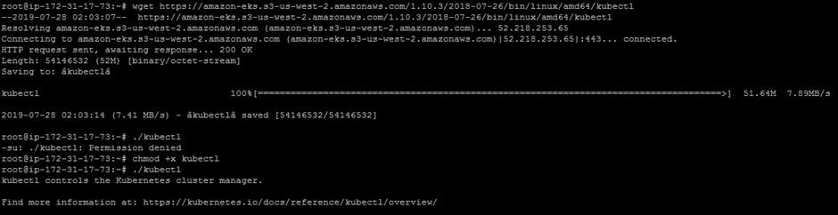

mkdir bin cp ./kubectl $HOME/bin/kubectl && export PATH=$HOME/bin:$PATH kubectl version

kubectl version --short –client

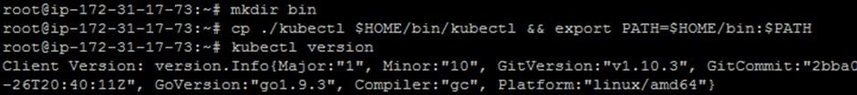

wget [https://amazon-eks.s3-us-west-2.amazonaws.com/1.10.3/2018-07-](https://amazon-eks.s3-us-west-2.amazonaws.com/1.10.3/2018-07-26/bin/linux/amd64/aws-iam-authenticator)

[26/bin/linux/amd64/aws-iam-authenticator](https://amazon-eks.s3-us-west-2.amazonaws.com/1.10.3/2018-07-26/bin/linux/amd64/aws-iam-authenticator) chmod +x ./aws-iam-authenticator

cp ./aws-iam-authenticator $HOME/bin/aws-iam-authenticator && export PATH=$HOME/bin:$PATH

aws-iam-authenticator help

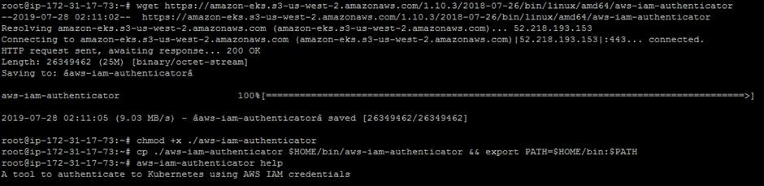

curl --silent --location

["https://github.com/weaveworks/eksctl/releases/download/latest_release/eksctl_$(una me](https://github.com/weaveworks/eksctl/releases/download/latest_release/eksctl_$(uname) -s)_amd64.tar.gz" | tar xz -C /tmp mv /tmp/eksctl /usr/local/bin eksctl version

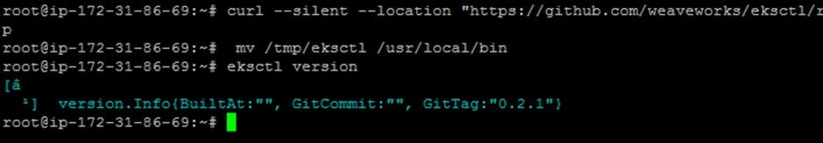

apt install python-pip pip install awscli aws –version

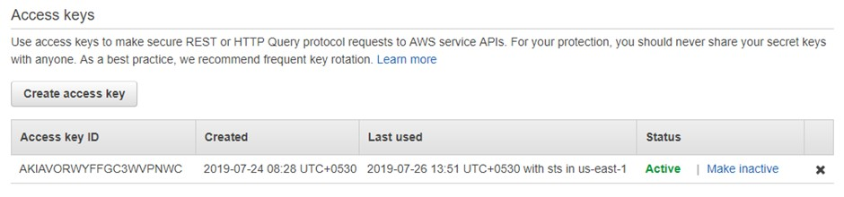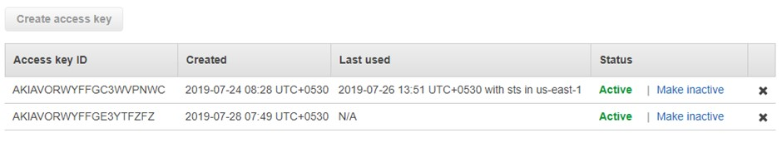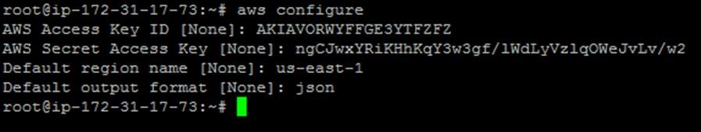

eksctl create cluster --name=EKSCluster --nodes=2 --region=us-west-2

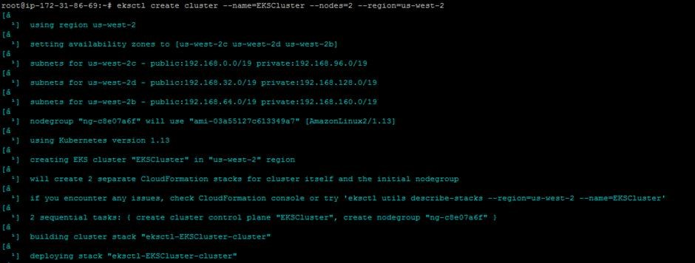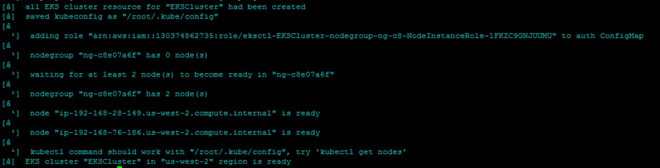

kubectl get node

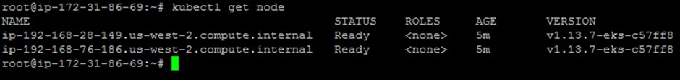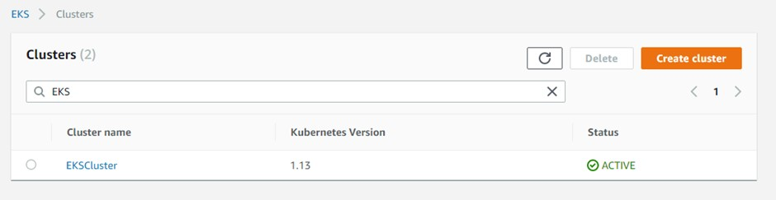

kubectl run kubernetes-bootcamp --image=docker.io/jocatalin/kubernetes-bootcamp:v1 -

-port=8080

kubectl expose deployment/kubernetes-bootcamp --port=8080 --target-port=8080 -type=NodePort

